

# **Health-Insurance Costs Set for a Jolt**

## For the Healthy, Rates Could Soar Under New Law; Sicker Consumers to See Relief

By [LOUISE RADNOFSKY](http://topics.wsj.com/person/A/biography/7253), THE WALL STREET JOURNAL, June 30, 2013

Healthy consumers could see insurance rates double or even triple when they look for individual coverage under the federal health law later this year, while the premiums paid by sicker people are set to become more affordable, according to a Wall Street Journal analysis of coverage to be sold on the law's new exchanges.

The exchanges, the centerpiece of President Barack Obama's health-care law, look likely to offer few if any of the cut-rate policies that healthy people can now buy, according to the Journal's analysis. At the same time, the top prices look to be within reach for many people who previously faced sky-high premiums because of chronic illnesses or who couldn't buy insurance at all.



Several big provisions in the law taking effect in six months affect rates for the estimated 20% of Americans who don't have coverage through an employer, Medicare or Medicaid. Plans must be available to consumers regardless of their health and must cover certain items such as hospitalization, maternity care and prescription drugs. The exchanges are set to open Oct. 1 selling plans effective Jan. 1.

A review of rates proposed by carriers in eight states shows the likely boundaries for the least-expensive and most costly plans on the exchanges. The lower boundary is particularly important because the government wants to attract healthy people to the exchanges, and they may choose to pay a penalty and take the risk of going without coverage if they believe they can't get an acceptable deal

For a 40-year-old single nonsmoker—in the middle of the age range eligible for exchanges—a "bronze" plan covering about 60% of medical costs will be available for about $200 a month in most places, the proposals show.

Though less generous than "silver" and "gold" plans on the exchanges, a bronze plan would still include fuller benefits than many policies available on the individual market today.

The challenge for the law is that healthy 40-year-olds can typically get coverage for less today, especially if they are willing to accept fewer benefits or take on more costs themselves. Supporters of the law say tighter regulation on insurance practices gives consumers more protection and is worth the extra cost, but they have to persuade people who don't have an immediate need for health care of that. If only sick people buy into the new insurance pools, prices could shoot up.

Bob Laszewski, a Virginia health-care consultant and former insurance executive, said the new offerings were likely to anger people who had preferred lower-cost products that were no longer available.

"If a person in 2013 has a choice of buying a Chevrolet or a Cadillac health plan, and in 2014, they can only buy a Cadillac…are they going to be upset? I think the answer is, yes," he said.

Virginia is one of the eight states examined by the Journal and offers a fairly typical picture.

In Richmond, a 40-year-old male nonsmoker logging on to the eHealthInsurance comparison-shopping website today would see a plan that costs $63 a month from Anthem, a unit of [WellPoint](http://online.wsj.com/public/quotes/main.html?type=djn&symbol=WLP) Inc. [WLP -0.17%](http://online.wsj.com/public/quotes/main.html?type=djn&symbol=WLP?mod=inlineTicker) That plan has a $5,000 deductible and covers half of medical costs.

By comparison, the least-expensive plan on the exchange for a 40-year-old nonsmoker in Richmond, also from Anthem, will likely cost $193 a month, according to filings submitted by carriers.

The law is likely to offer a benefit to those who have difficulty getting insurance now or are pushed out of the market because they have had illnesses. Under the current system, the rate on the $63-a-month plan could be revised higher if a consumer indicates prior health problems in a medical questionnaire that must be filled out before buying the plan. The application also could be rejected entirely based on specific answers given.

Under the new health exchanges, plans are available regardless of health status, and a price can't change once it is offered. Top-of-the-line plans on the exchanges that cover 80% of medical costs and have a wider network of doctors and hospitals are likely to be available for about $400 a month for a 40-year-old single person.

That is a lot of money for the lower-to-middle-income Americans who are expected to be the main customers on exchanges, but it could be less than some people currently encounter after a carrier considers their medical history.

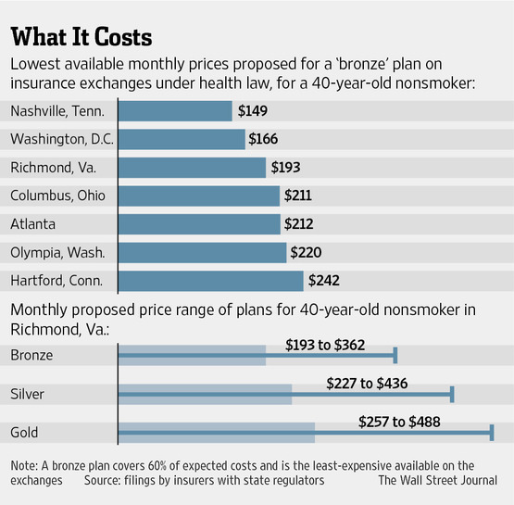

Those without coverage face out-of-pocket medical bills in the tens of thousands of dollars if they get sick.

"The quality of the coverage is transparent, so you know what is covered and that you can count on it, without having to worry that your coverage will end when you need it the most," said Joanne Peters, a spokeswoman for the Department of Health and Human Services.

Consumers in states that aren't creating their own health exchanges will use an exchange run by the federal government. Americans who already get health coverage on the job or through Medicare or Medicaid are likely to be affected more by other elements of the 2010 Affordable Care Act, such as those encouraging doctors and hospitals to cut back on inefficient care. On the exchanges, not everybody will have to pay the prices in full, because the law offers some income-based subsidies toward the cost of premiums.

A 40-year-old with income near the poverty level—currently $11,490 a year for a single person—would likely qualify for a subsidy of as much as $234 a month toward the cost of premiums in Virginia, potentially covering the entire cost of a bronze plan.

Any subsidy in Virginia would vanish once an individual reached annual income of about $33,150.

Tom Perriello, who voted for the law as a Democratic House member from Virginia and who now works for the left-leaning Center for American Progress, called the costs of premiums "a work in progress" and added, "Over the next few years, we should see that cost curve bend."

Prices may change slightly in some states before the fall, and the picture for 2015 and beyond is fuzzy.

Some carriers have been more cautious in judging the risks of the new market, and several large insurers are mostly sitting out the exchanges for the first year to see how they work.

[UnitedHealth Group](http://online.wsj.com/public/quotes/main.html?type=djn&symbol=UNH) Inc. [UNH +0.27%](http://online.wsj.com/public/quotes/main.html?type=djn&symbol=UNH?mod=inlineTicker) and [Humana](http://online.wsj.com/public/quotes/main.html?type=djn&symbol=HUM) Inc. [HUM +0.88%](http://online.wsj.com/public/quotes/main.html?type=djn&symbol=HUM?mod=inlineTicker) both currently sell a range of products in Richmond but haven't proposed to sell through the exchange, according to the Virginia State Corporation Commission.

The companies declined to comment on the commission's list of proposals.

<http://online.wsj.com/article/SB10001424127887324251504578577760224985382.html>